Application No...………………
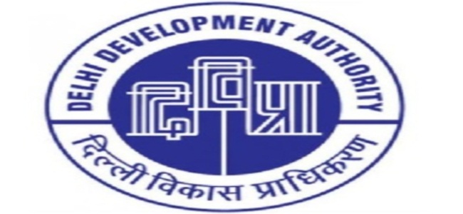
DELHI DEVELOPMENT AUTHORITY
DWARKA SPORTS COMPLEX

Attach coloured Passport Size photograph
SECTOR 11 DWARKA NEW DELHI-110075
SPECIAL TEMPORARY MEMBERSHIP APPLICATION FORM
FOR OFFICE USE:-
Membership No.

Date of Membership / /
_______________________________________________________________________________________________

- Name (in Block Letters)
- Father’s/ Husband’s Name
- Residential Address
PIN
- Office Address
PIN

- Mobile No.
(Mandatory)
- Email ID
(Mandatory)

- Occupation S-Service, B-Business, P-Profession, O-Others

- Details of Occupation

- Date of Birth

- Gender M-Male, F-Female, O- Any Other Category

- Marital Status S-Single, M-Married

- Nationality I-Indian, F-Foreign

- Educational Qualification 1. HSS, 2.Graduate, 3. Post Graduate, 4.Technical Graduate 5. Others

- Details of Dependents (including spouse)* who are to be enrolled.

Name
Attach Photo

Attach Photo

Attach Photo

Relation Date of Birth

Name

Relation Date of Birth

Name

Relation Date of Birth

Name
Attach Photo

Relation Date of Birth

- S-Son, D-Daughter, W-Wife, H-Husband
Note: -Document Required Prior Allotment of Membership.
- Residence/ ID Proof
- Please attach the photocopy of Service Certificate as proof of Central govt. employee.
- Age Certificate of Self, Spouse and dependent members.
- Two Photographs for each Member
- Children between 5 to 21 years can be dependent members.

- I enclose here with Demand Draft No…………………….………..…dated…………….…………….……. drawn on …………………………………………………………………in favour of “CAU SPORTS, DDA” for an amount of Rs………………(Rupees…………………………………………………………………………………………………..only)
(This is applicable when not paying by Debit / Credit Card)

- Undertaking
- All information furnished above are correct. However, my application form is liable to be rejected if details found to be incorrect.
- I have read the Rules and Regulation Bye-laws contained in the brochure of Dwarka Sports Complex and undertake to abide by the same.

Date………………………. (Signature of Applicant)

----------------------------------------------------------------------------------------------------------------------------------------------------------------------------------
FOR OFFICE USE ONLY: - ACKNOWLEDGEMENT Application No. ……………………
DELHI DEVELOPMENT AUTHORITY
DWARKA SPORTS COMPLEX, NEW DELHI

Received from Mr./Ms./Mrs…………………………………………………Application for STM membership of DSC and an amount of Rs……………(Rupees……………………………………………………………………………..only) in the form of Demand Draft No……………….Dt……………….Drawn on…………………..…….in favour of ‘’CAU SPORTS,DDA’’ or through Debit or Credit Card.

Date…………….. (Signature of the Receiving Clerk with Stamp)

GUIDELINES FOR SPECIAL TEMPORARY MEMBERSHIP
OF DWARKA SPORTS COMPLEX

- Only one application should be submitted by an individual.
- Filled in downloaded application forms should be submitted at Admin Block Reception during working hours (10:00 a.m to 3.00 p.m) except lunch hours from 01:30 to 02:00p.m at the complex.
- Membership will be allotted after approval.
- Candidate will be required to deposit Entry Fee of Rs. 4000 + GST (Non-refundable). Pay Order/Demand Draft should be drawn in favour of “CAU SPORTS, DDA” or pay through Credit or Debit Card.
- Documents required to be submitted by the Candidates:-
- Residence/ ID Proof
- Please attach the photocopy of Service Certificate as proof of Central govt. employee.
- Age Certificate of Self, Spouse and Dependent members.
- Two Photographs for each Member
- Children between 5 to 21 years can be dependent members.

6. STM membership is valid for One year and further extendable by one year with additional charges (as applicable). No further extension permitted.

